**UK HOUSE PRICE**

**REPORT**

**From January 2020 to September 2022**

**Damilola Afolabi Adeosun**

Data Analyst

**Table of Contents**

**Introduction** 03

**UK House Distribution Statistics** 04

**Property Types** 06

**Price Trends** 07

**i By Country** 10

**Ii By Property Type** 11

**Detached House** 12

**Semi-Detached House** 14

**Terraced House** 17

**Newly Built House** 20

**Established Residential Houses** 24

**Summary** 28

**Conclusion** 30

## 

## **INTRODUCTION**

This report aims to create insights for the international property developer to know about the property market in the U.K. The insights will be unveiled for the last three years: 2020, 2021, and 2022. The dataset was downloaded from the official site of UK house prices and contains data within a duration from January 2020 to September 2022. After downloading the datasets, the datasets are wrangled (assessed and cleaned), and then the following insights are uncovered, among others.

* Price trends by location
* property type, sales trends by location
* sales trends by other developers
* Price of new builds by location

From the year 2020, the prices of houses gradually increased monthly and reached their peak in June 2021, when the average price of houses was above £260,000. It then gradually decreased from the month of June into July 2021, when house prices were at their lowest, with an average price below £210,000. House prices started to increase again until the month of September, when they began to fall progressively and then later rose into the year 2022.

**UK House Distribution Statistics**

**By property type:**

92.69% of the houses are newly built residents while 7.31% are residents that are already established. Hence, there are more new residents than already established residents.

**By ownership:**

22.46% are leaseholds, while 77.54% are freeholds. Hence, there are more people who own their own houses as opposed to the population of people who lease.

**By Pricing:**

88.02% of house owners use the standard price, while 11.98% add prices to the standard price.

**By Location**

**Streets:**

The top 10 street distributions are High Street, Station Road, London Road, Church Street, Main Street, Church Road, Park Road, Victoria Road, Main Road, and New Road. There are 12623 counts for the high street, 6675 counts for station road, 4249 counts for London Road, 3588 counts for Church Street, 3565 counts for Main Street, 3269 counts for Church Road, 2703 counts for Park Road, 2509 counts for Victoria Road, 2242 counts for Main Road, and 2191 counts for New Road.

The following have the least count: Malters Cottages, Corve View, Blodwen Terrace, Summerley Close, Flash Street, Harmans Mead, Church Close Mews, St Pegas Road, Bearsden Way, Wild Avenue

**Localities:**

The top 10 localities are Middleton, Shirley, Kingswood, Worsley, Long Eaton, Hucknail, Eccles, Moreley, Urmston, and Beeston. Middleton has 2392 counts, Shirley has 2150 counts, Worsley has 1832 counts,

Kingswood has 1812 counts, Long Eaton has 1737 counts, Urmston has 1623 counts, Hucknail has 1612 counts, Eccles has 1544 counts, Moreley has 1519 counts, and Beeston has 1540 counts.

The following localities have the least count: Grizedale, Ashtead, Bessingham, Higher Brill, Trelyon, Polurrian Cliffs, Tolgullow, Pinkney, Stoketon, Nadderwater

**Cities:**

The top 10 cities are London, Manchester, Birmingham, Nottingham, Bristol, Liverpool, Leeds, Sheffield, Leicester, and Norwich. London has 54048 counts, Manchester has 37340 counts, Birmingham has 31271 counts, Nottingam has 29427 counts, Bristol has 29287 counts, Leeds has 24271 counts, Liverpool has 23124 counts, Sheffield has 20108 counts, Leicester has 18516 counts, and Norwich has 15941 counts.

The following have the least count: Port Dinorwic, Kelso, Llansanffraid, Dulas, Gretna, Mindrum, Rhosgoch, Marianglas, Newcastleton, Llanbedrgoch

**Countries:**

The top 10 countries are Greater London, Greater Manchester, the West Midlands, West Yorkshire, Kent, Essex, Lancashire, Merseyside, South Yorkshire, and Hampshire. Greater London has a count of 113686, Greater Manchester has a count of 99549, the West Midlands has a count of 83271, West Yorkshire has a count of 81361, Kent has a count of 55070, Essex has a count of 50065, Lancashire has a count of 49181, Merseyside has a count of 47777, South Yorkshire has a count of 45496, and Hampshire has a count of 44635.

The bottom 10 countries are Isles of Scilly, Rutland, Merthyr Tydfil, Blaenau Gwent, Windsor and Maidenhead, Isle of Anglesey, Ceredigion, Slough, Hartlepool, and Monmouthshire.

Rutland has a count of 1257, Merthyr Tydfil has a count of 1585, Bleaneau Gwent has a count of 1878, Windsor and Maidenhead have a count of 2545, the Isle of Anglesey has a count of 2677, Ceredigion has a count of 2745, Slough has a count of 2858, Hartlepool has a count of 2855, and Monmouthshire has a count of 3164.

## 

## **Properties with Highest Sales**

The semi-detached house, which comprises two houses coupled together by a single wall, has the highest sales, with a count of above 500,000. More so, terraced houses also have a count above 500,000 and are the second highest in terms of sales. These property types occur in rows that are attached on both sides to other houses and are prevalent in larger cities with denser populations.

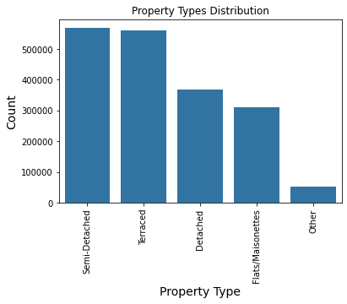

Detached houses are single houses that are not connected to another house or building. They have the third highest sales, with a count of around 350,000. This is because they are usually extremely expensive. Flats and maisonettes have the fourth highest sales, with around 300,000 units. These types of houses are most popular in more urban/city-like areas such as London and Birmingham. This is because they save a lot of space and provide accommodation for many people within a single building. Other property types, such as cottages, bungalows, and mansions have less than 100,000 counts.

**PRICE TREND**

## **Monthly:**

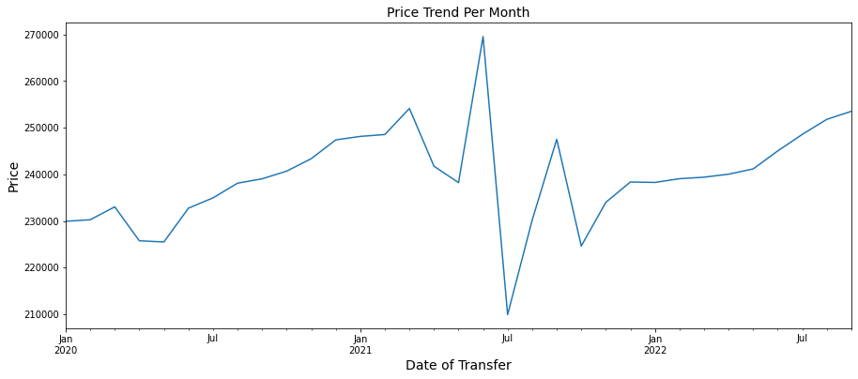

From the year 2020, the prices of houses gradually increased monthly and reached their peak in June 2021, when the average price of houses was above £260,000. It then gradually decreased from the month of June into July 2021, when house prices were at their lowest, with an average price below £210,000. House prices started to increase again until the month of September when they began to fall progressively and then later rose in the year 2022.

### 

### 

### 

### 

### 

### **Quartiles Per Year:**

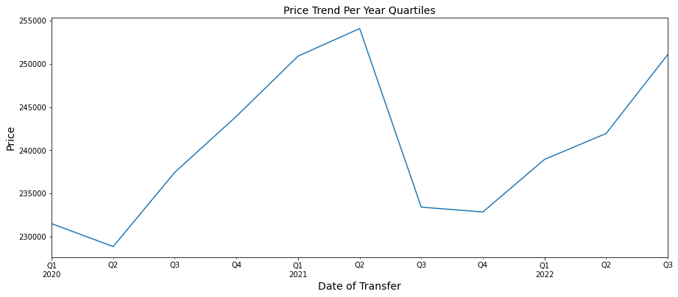

House prices were the highest in the second quarter of 2021, with an average price of more than £250,000, while house prices were the lowest in the second quarter of 2020, with an average price below £230,000. Hence, the drop in sales in the second quarter of 2020 might be an effect of COVID-19.

## 

## 

## **Annually:**

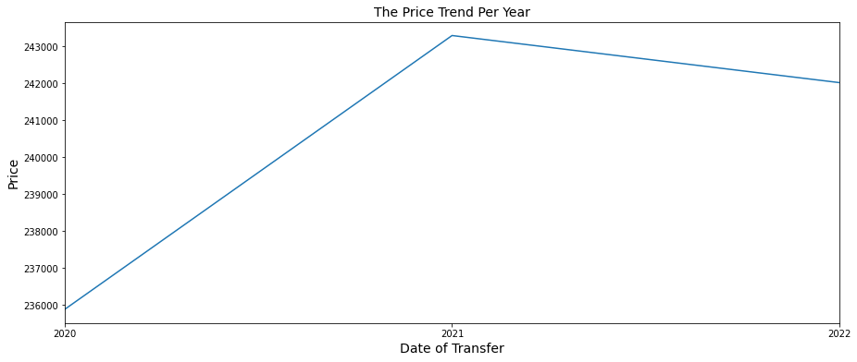

There was a steady increase in price from 2020 to 2021, when house prices were at their peak. This is followed by a little drop in price from 2021 into 2022. Hence, 2021 has the highest price with an average price above £243000, while house prices were the lowest in 2020 with a price below £236000.

## 

## **Average Price By Country**

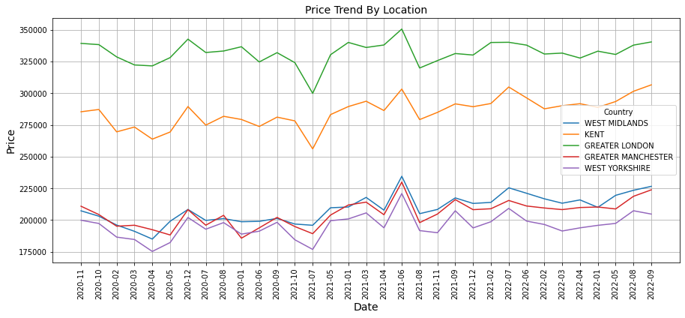

The price of houses in Greater London rose to the peak in June 2021 with an average price of £350,000 and fell to the minimum in July 2021 with an average price of £300,000.

Moreover, the price of houses in Kent was at its highest in September 2022. The average price was around £305,000. The lowest is in July 2021, with an average price of £255,000.

In the West Midlands, prices were at their highest in June 2021, with an average price of around £230,000. The lowest was in April 2020, with an average price of around £185,000.

Greater Manchester's house prices rose to their peak in June 2021, when the average price was around £227,000, and fell to the bottom in January 2020, with an average price of around £185,000.

West Yorkshire has its highest house price in June 2021 with an average price of £220,000 and its lowest house price in April 2020 with an average price of around 175,000.

As a result, in the majority of UK countries, houses were more expensive in June 2021 and less expensive in July 2021.

## 

## **Average Price by Property Type**

### 

### The detached property type reaches its highest peak in September 2022, at over £320,000, and its lowest peak is in July 2021, at around £277,000.

### 

### The semi-detached property type has its highest peak in June 2021 at £261,000 and the lowest peak in July 2021 at around £210,000.

### The flats and maisonettes property type has its highest peak in June 2021, which is around £255,000, and its lowest peak in July 2021, which is below £195,000.

### 

### Terraced property has its highest peak in June 2021, which is around £243000, and its lowest peak in July 2021, which is below £190000.

### 

### Hence, we can say there is a reoccurring pattern: the majority of the property types have their highest peak in June 2021, while the majority of the property types have their lowest peak in July 2021.

### 

**Detached Trend by Country**

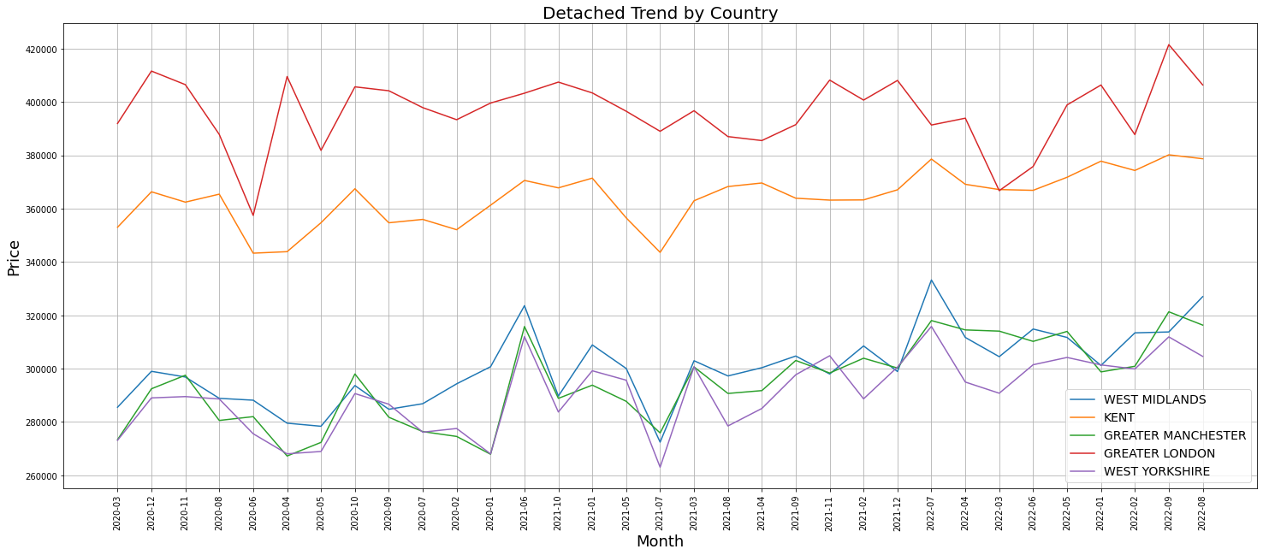

* At the country level, the largest annual Detached price is Greater London. The highest peak is observed in September 2022 and is above £420000 while the lowest peak is observed in June 2020 and is £359000
* Kent: The highest peak of the price is observed in September 2022 and is ab £380000 while the lowest peak is observed in June 2020 and is £358000
* Greater Machester: The highest peak of the price is observed in September 2022 and is £320000 while the lowest peak is observed in April 2022 and is £270000
* West Midlands: The highest peak of the price is observed in July 2022 and is £338000 while the lowest peak is observed in July 2021 and is £278000
* West Yorkshire: The highest peak of the price is observed in July 2022 and is £310800 while the lowest peak is observed in July 2021 and is £264000

#### 

#### 

#### **Annual price change for the top 5 countries over the past 3 years for detached house**

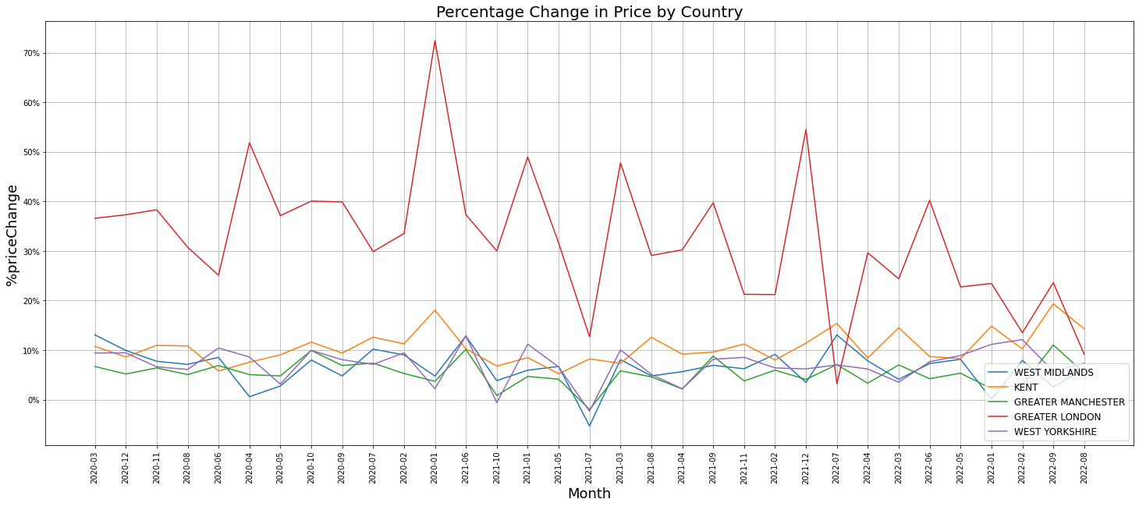

* Greater London had the highest annual detached home price growth in the country from January 2020 to September 2022, with house prices increasing by 24%. The highest peak of the price growth is observed in January 2022 and is above 70%, while the lowest peak is observed in July 2022 and is 4%.
* Detached house prices in Kent increased by 19% from January 2020 to September 2022. The highest peak of the price growth is observed in September 2022 and is a 19% increase, while the lowest peak is observed in June 2022 and is a 6% increase.
* From January 2020 to September 2022, detached house prices in Greater Manchester increased by 11%. The highest peak of the price growth is observed in June 2021 and is a 10% increase, while the lowest peak is observed in July 2021 and is an 8% increase.
* From January 2020 to September 2022, detached house prices in the West Midlands rose by 4%. The highest peak of the price growth is observed in March 2020, July 2020, and June 2021, and is 12%, while the lowest peak is observed in July 2021 and is a -6% increase.
* West Yorkshire detached house prices increased by 0.6% between January 2020 and September 2022. The highest peak of the price growth is observed in June 2021 and is 12% higher, while the lowest peak is observed in July 2021 and is 0% higher.

## 

## **SEMI-DETACHED PROPERTIES STATISTICS**

**The Annual average price of a semi-detached property in the Greater London area from January 2020 to September 2022 was**

**£380500**

**The Annual semi-detached property in Greater Manchester cost an average of**

**£250000 from January 2020 to September 2022 was**

**The annual price change for a semi-detached property in the Greater London was**

**33%**

**The annual price change for a semi-detached property in the Greater Manchester was**

**12%**

## 

## **Semi-detached Trend by Country**

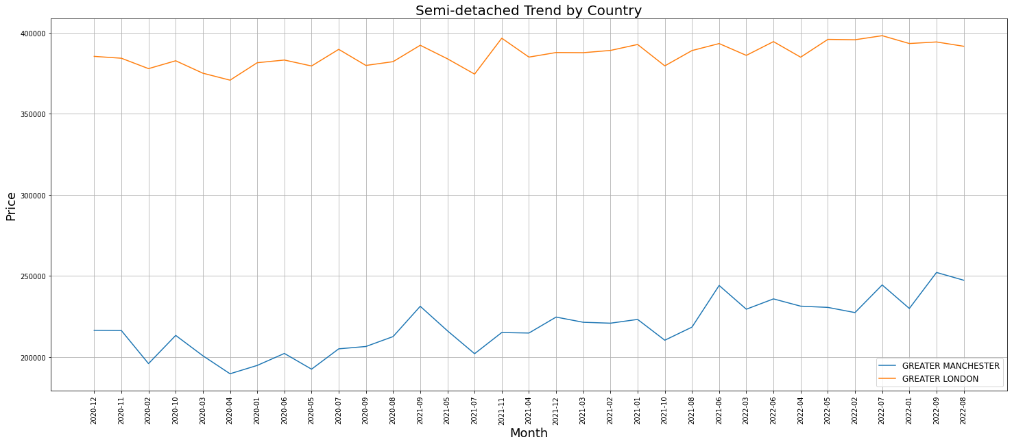

* Semi-detached in Greater London has its highest peak in July 2022 with an average price of £399500 and its lowest peak in April 2020 with an average price of £370000.
* Semi-detached in Greater Manchester has its highest peak in September 2022 with an average price of £250200 and its lowest peak in April 2020 with an average price below £200000.

## 

## 

## 

## 

## 

## 

## **Semi-Detached Percentage Change in Price by Country**

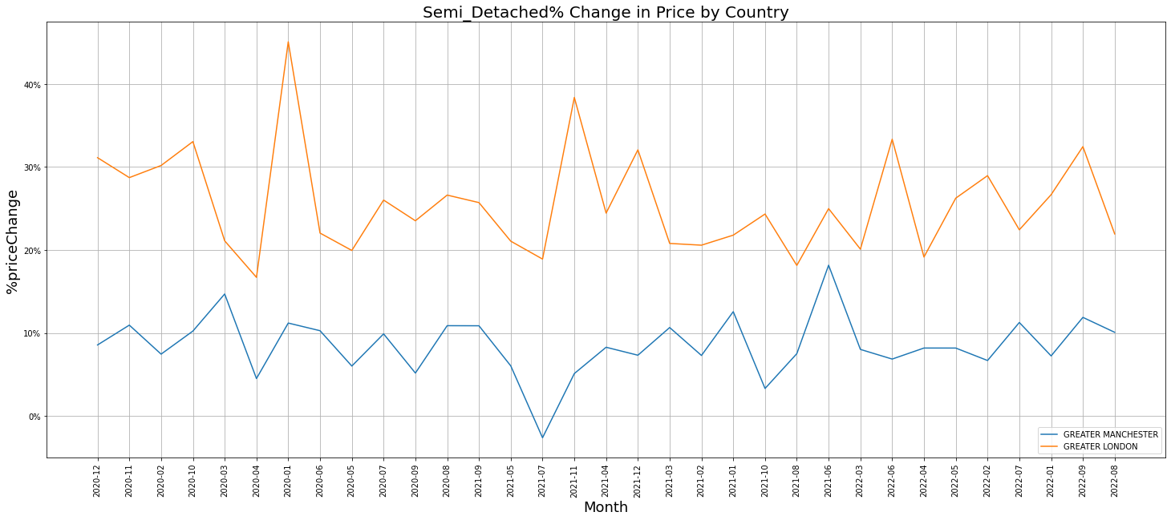

* From January 2020 to September 2022, semi-detached house prices in Greater London increased by 33%. The highest peak of the price growth is observed in January 2020, at 47%, while the lowest peak is observed in April 2020, at 17%.
* Semi-detached house prices in Greater Manchester increased by 12% from January 2020 to September 2022. The highest peak of the price growth is observed in June 2021 and increased by 18%, while the lowest peak is observed in July 2021 with a -5% growth rate.

## 

## 

## 

## 

## **Terraced Statistics**

**The annual average price of a Terraced property in the Greater London area from January 2020 to September 2022 was**

**£380000**

**Terraced annual average house price in Greater Manchester cost an average of**

**£180000 from January 2020 to September 2022**

**The annual price change from January 2020 till September 2022 for a Terraced property in the Greater London was**

**22.5%**

**The annual price change from January 2020 to September 2022 for a Terraced property in Greater Manchester was**

**14%**

## 

## **Terraced Trend by Country**

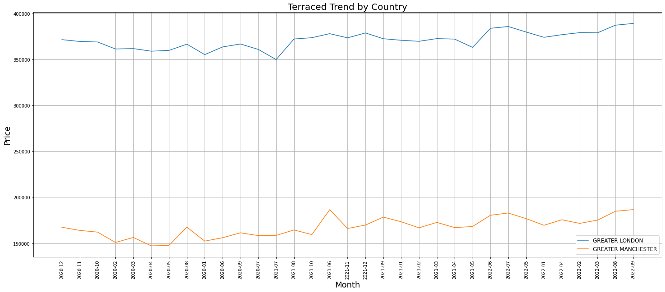

* Terraced house in Greater London has its highest peak in September 2022 with an average price of £380000 and its lowest peak in July 2021 with an average price of £350000.
* Terraced house in Greater Manchester has its highest peak in June 2021 with an average price of £180000 and its lowest peak in April 2020 with an average price below £150000

## 

## **Terraced Percentage Change in Price by Country**

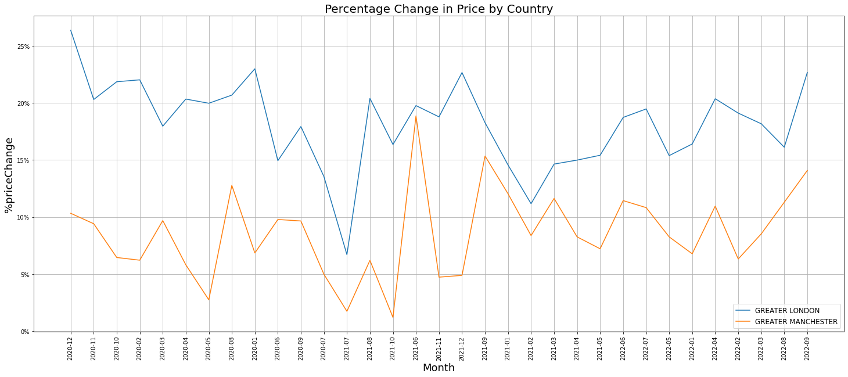

* From January 2020 to September 2022, Terraced house prices in Greater London increased by 22.5%. The highest peak of the price growth is observed in December 2020 and it is 27%, while the lowest peak is observed in July 2021 with a 7% growth rate.
* Terraced house prices in Greater Manchester increased by 14% in from January 2020 to September 2022. The highest peak of the price growth is observed in June 2021 and is 18%, while the lowest peak is observed in October 2021 with a 0.2% growth rate.

NEWLY BUILT PROPERTIES

### **Trend in Price of Newly Built Houses**

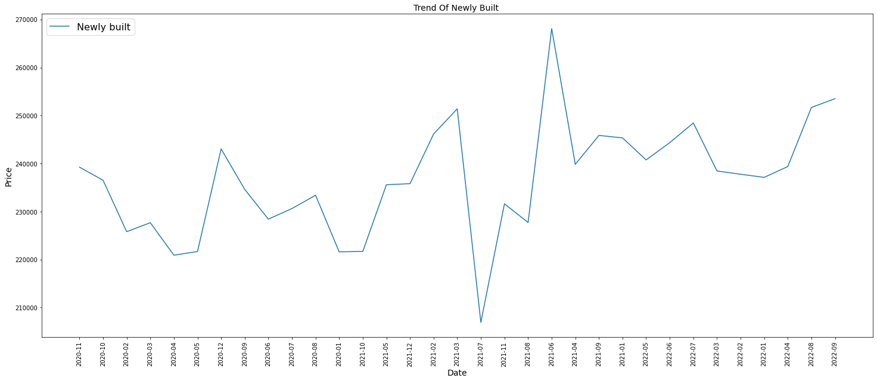

The price of newly built houses was scaled to be highest in June 2021, when it was above £260000, and lowest in July 2021 when it was less than £210000.

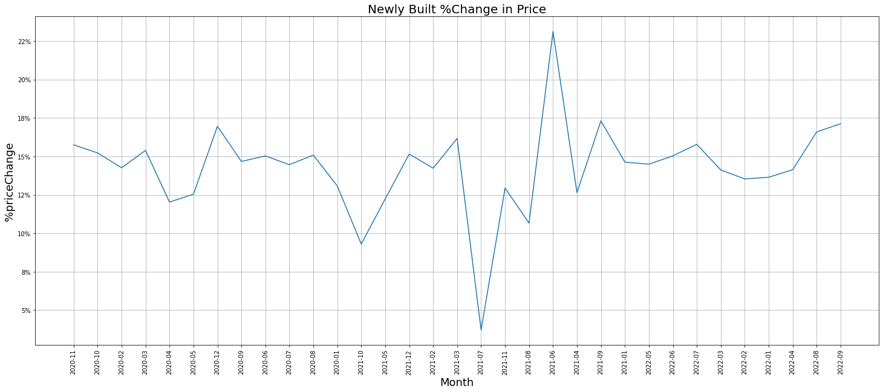

Newly built houses increased by 17.8% from January 2020 to September 2022. The highest peak of the price growth is observed in June 2021 and increased by 24%, while the lowest peak is observed in July 2021 with a 3% growth rate.

## **Newly Built Property Sales**

## 

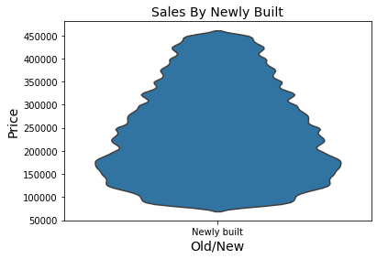

Newly built distribution is more concentrated at a little below £200000, while its highest price is £450000. This implies that newly built houses sold the highest when the price was a little below £200,000 and sold the least when the price was £450,000.

## 

## 

## 

## 

## 

## 

## 

## **Newly Built House Price Distribution Relative to Price by Country**

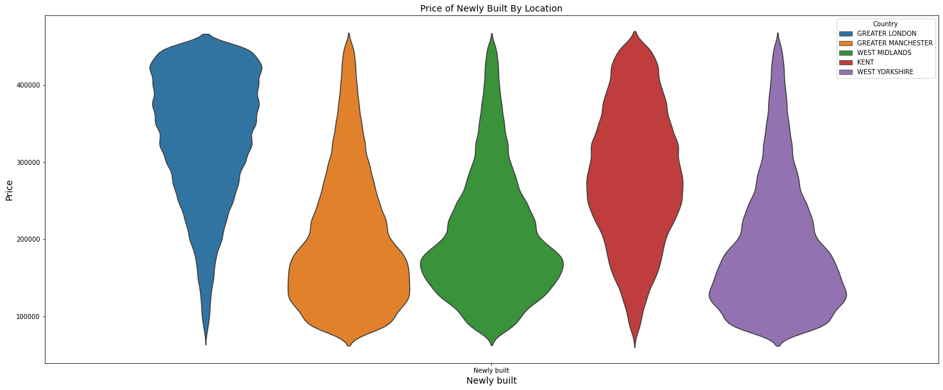

The five countries have their highest prices at £450,000. Greater London's price is more concentrated above 450000; Greater Manchester, West Yorkshire, and the West Midlands are more concentrated below 200,000; and Kent is more concentrated around 250000.

## 

## 

## 

## 

## 

## 

## 

## 

## 

## 

## 

## **Newly Built House Price Distribution Relative to Price by Property Type**

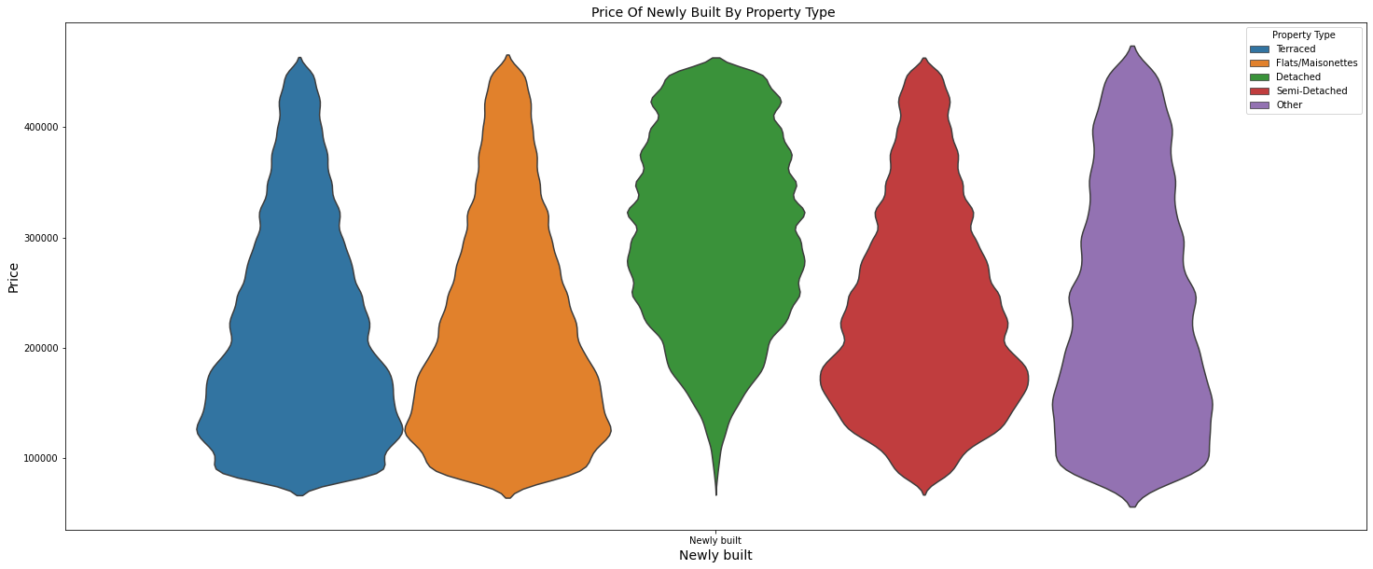

The highest price for the four property types is £450,000, with detached houses more concentrated at around £300,000, flats/maisonettes and terraced houses more concentrated at £130,000, and semi-detached more concentrated at around £170,000.

This shows that more people tend to buy newly built detached houses for around £300,000. Flats/maisonettes and terraced houses for around £130,000, and semi-detached houses for around £170,000.

## 

## 

## 

## 

## 

## 

## 

## **ESTABLISHED RESIDENTIAL PROPERTIES**

## **Trend of Established Residential**

## The lowest peak is observed in July 2021 with an average price of £255000, while the highest peak is observed in February 2022 with an average price of £290000.

## 

## 

## 

## 

## 

## 

## **Established Residential Percentage Change in Price**

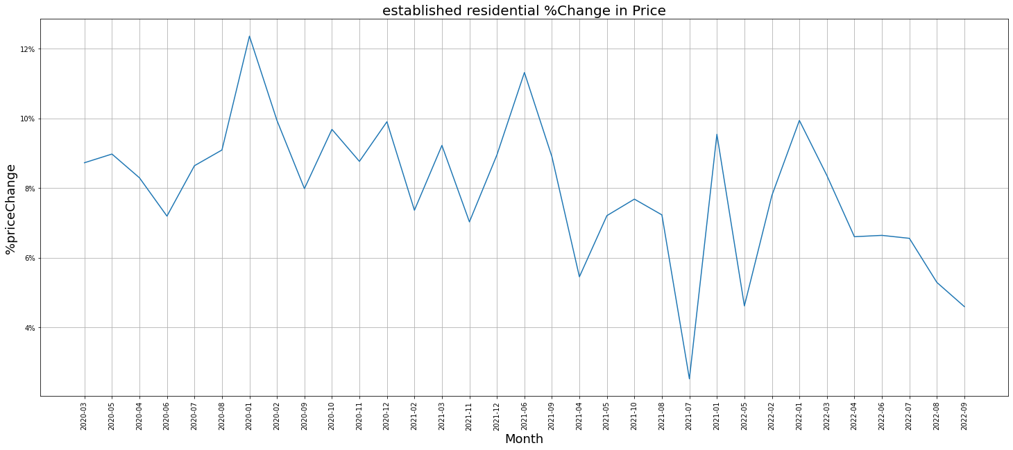

Established residential increased by 4.5% between January 2020 and September 2022.

The highest peak of the price growth was observed in January 2022 and increased by 12.5%, while the lowest peak was observed in July 2021 with a 3% growth rate.

## 

## **Sales by Established Residential**

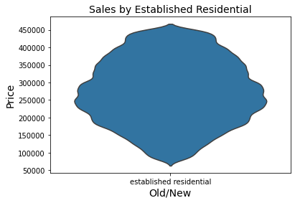

Established residential distribution is more concentrated around £250000, while its highest price is £450000.

## **Established Residential House Price Distribution Relative to Price by Country**

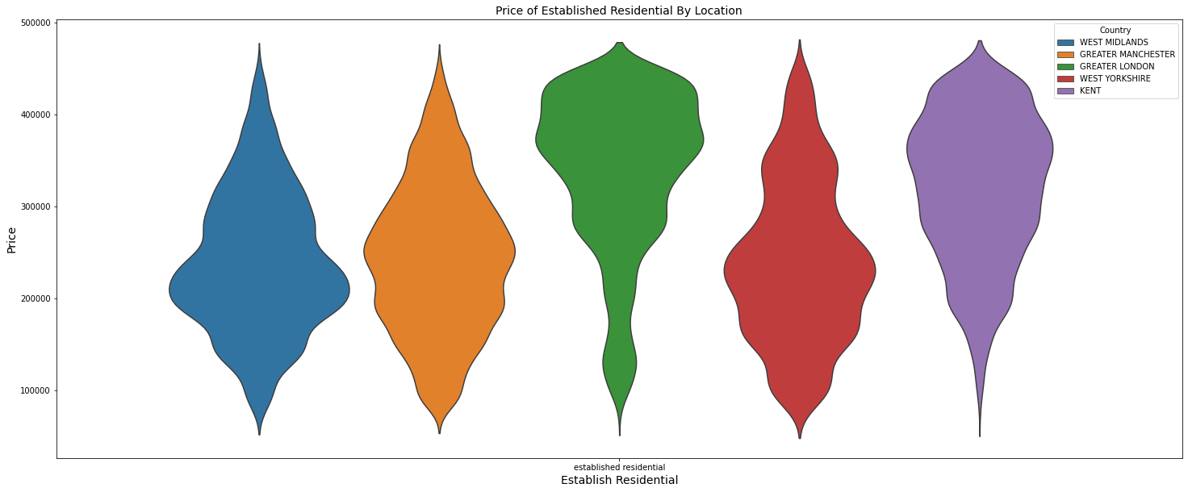

The five countries have their highest prices at £450,000. Greater London's price is more concentrated around £380000; Greater Manchester's price is more concentrated around £280000; West Yorkshire's price is more concentrated around £250000; the West Midlands is more concentrated around £220000, and Kent is more concentrated around £350000.

## 

## **Established Residential House Price Distribution Relative to Price by Property Type**

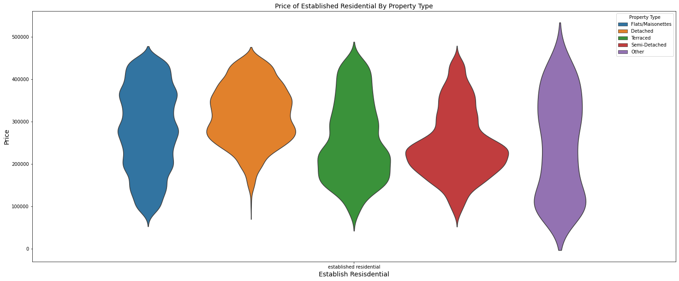

Detached houses are more concentrated at around £280000, flats and maisonettes are more concentrated at around £380000 and £280000, and terraced houses are more concentrated from £150000 to £200000, while semi-detached houses are more concentrated at around £200000.

# 

# 

# 

# 

# 

# 

# 

**SUMMARY**

|  |  |  |  |  |  |
| --- | --- | --- | --- | --- | --- |
| **Country** | **Country Count** | **Locality** | **Locality Count** | **Street** | **Street Count** |
| **Greater London** | **113686** | **Middleton** | **2392** | **High Street** | **12623** |
| **Greater Manchester** | **99549** | **Shirley** | **2150** | **Station Road** | **6675** |
| **West Midlands** | **83271** | **Kingswood** | **1832** | **London Road** | **4249** |
| **West Yorkshire** | **81361** | **Worsley** | **1812** | **Church Street** | **3588** |
| **Kent** | **55070** | **Long Eaton** | **1737** | **Main Street** | **3565** |
| **Essex** | **50065** | **Urmston** | **1623** | **Church Road** | **3269** |
| **Lancashire** | **49181** | **Hucknail** | **1612** | **Park Road** | **2703** |
| **Merseyside** | **47777** | **Eccles** | **1544** | **Victoria Road** | **2509** |
| **South Yorkshire** | **45496** | **Moreley** | **1519** | **Main Road** | **2242** |
| **Hampshire** | **44635** | **Beeston** | **1540** | **New Road** | **2191** |

Based on the geographical distribution, the following deductions can be shown in a tabular form, as seen below:

|  |  |  |  |  |
| --- | --- | --- | --- | --- |
| **Country** | **Highest Average Month** | **Highest Average Price** | **Lowest Average Month** | **Lowest Average Price** |
| **Greater London** | **June 2021** | **350,000** | **July 2021** | **300,000** |
| **Kent** | **September 2022** | **305,000** | **July 2021** | **255,000** |
| **West Midlands** | **June 2021** | **230,000** | **April 2020** | **185,000** |
| **Greater Manchester** | **June 2021** | **227,000** | **January 2020** | **185,000** |
| **West Yorkshire** | **June 2021** | **220,000** | **April 2020** | **175,000** |

**Average Price by Country**

**Average Price By Property Type**

|  |  |  |  |  |
| --- | --- | --- | --- | --- |
| **Property Type** | **Highest Average Month** | **Highest Average Price** | **Lowest Average Month** | **Lowest Average price** |
| **Detached** | **September 2022** | **320,000** | **July 2021** | **277,000** |
| **Semi-Detached** | **June 2021** | **261,000** | **July 2021** | **210,000** |
| **Flat and Montesorri** | **June 2021** | **255,000** | **July 2021** | **195,000** |
| **Terraced** | **June 2021** | **243,000** | **July 2021** | **190,000** |

**Conclusion**

London has the highest sales despite the fact that the houses there are expensive. This is because London is a cultural hub in the UK with an abundance of opportunities. London has long been a popular place to live due to its plethora of job opportunities and culture. However, with rising house prices and the cost of living increasing in London, more and more people are choosing to live outside of the capital.

Semi-detach house has the highest sales, the fact they are smaller than detached houses, making them ideal for first-time buyers who don’t have as much money to spend. In addition, they are also good choices when it comes to maintenance costs because you have fewer materials that need maintenance in comparison to a fully detached house due to the fact that you have shared walls.

UK house prices fell in July after a coronavirus emergency tax break for buyers was scaled back at the end of June.

**References**

# William, S., Kelvin, L., & Crimmins, C.( 2021, July 28). *UK house prices fall in July as tax cut is scaled back-Nationwide.* https://www.reuters.com/business/finance/uk-house-price-growth-cools-tax-cut-deadline-passes-nationwide-2021-07-28/

# Guidance.(2014, August 14). *How to access HM Land Registry Price Paid Data.* https://www.gov.uk/guidance/about-the-price-paid-data